DATA HANDLING AND DATA VISUALIZATION FOR SPHERE-DSA0610
DAY:- 1
- AIM:- Visualize Scatter plot for given dataset.

ALGORITHM:-
- Load library.
- Create data frame.
- Initialize ggplot() with data and aesthetics.
- Add a geometric layer (geom_point, geom_line, etc.).
- Customize labels and theme.
- Render/display plot.

PROGRAM:-
# Load necessary library
library(ggplot2)

# Create a data frame
weight_height_data <- data.frame(
Weight = c(60, 65, 70, 72, 75),
Height = c(170, 175, 168, 180, 178)
)

# Plot scatter plot
ggplot(weight_height_data, aes(x = Weight, y = Height)) +
geom_point(color = "blue", size = 3) +
labs(
title = "Weight vs. Height",
x = "Weight (kg)",
y = "Height (cm)"
)
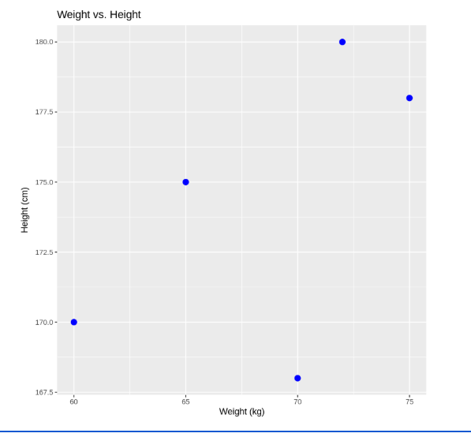

- AIM:-Visualize a Line Plot for the Given Population Data

ALGORITHM:-
- Load the required library.
- Create the data frame.
- Initialize ggplot() with data and aesthetics.
- Add line and/or point layers (geom_line(), geom_point()).
- Customize labels (labs()) and theme (theme_*()).
- Render the plot.

PROGRAM:-
# Load necessary library
library(ggplot2)

# Create a data frame
year_population_data <- data.frame(
Year = 2010:2014,
Population = c(1000, 1020, 1040, 1060, 1080)
)

# Plot line plot
ggplot(year_population_data, aes(x = Year, y = Population)) +
geom_line(color = "green", size = 1) +
geom_point(color = "red", size = 3) +
labs(
title = "Year vs. Population",
x = "Year",
y = "Population (millions)"
) +
theme_minimal()

OUTPUT:-

